Exercise: Product launch analysis

Introduction
In the previous week of this course, you discovered more about the stages in the data analysis process, focusing on data collection, processing, and transformation. You learned that data analysts need to identify and engage with stakeholders, identify data sources, and evaluate the data early in the data analysis process. In this exercise, you’ll engage with these tasks to consolidate your learning.

Case study
You’re a part of the data analytics team at Adventure Works. The lead data analyst, Adio, informs you that the company wants an in-depth analysis of sales data from the past year to understand sales trends and customer preferences. This isn't a routine analysis. The company is close to launching a new product line next quarter. Your analysis and insights will guide this massive product launch, including the marketing strategy, sales approach, and even the final tweaks to the product! Each number, trend, and pattern you uncover from the dataset could directly impact hundreds of decisions.
You are assigned some initial tasks related to stakeholder engagement, data collection, and data processing—some early steps in the data analysis process that will contribute to the success of the project.

Instructions
Create a new Word document and name it Product launch analysis. Follow the prompts below to complete the exercise.

Step 1: Identify the stakeholders
Understanding who the stakeholders are in a given scenario is a critical step in any data analysis project. In this case, you identify stakeholders (individuals or groups) within the company that will be directly affected by, or have a direct interest in, the sales trends and customer preferences that your analysis will reveal. These include the sales, marketing, and product development teams.
Now, answer the following questions related to stakeholder identification:
- Briefly explain why any two of the stakeholder groups at Adventure Works may have an interest in the insights related to the sales performance of various products.
- Which of the stakeholders need to know about customer preferences when it comes to Adventure Works’ products? Why is this information important for them? (Note: Customer preferences refer to customer wants, needs, and expectations regarding products and/or services.)

Step 2: Identify and consider the data sources
Download the Sales.csv file below and open it in Microsoft Excel.
Sales
CSV File
This dataset contains valuable information that will be key to your analysis. The spreadsheet contains various fields, including:
- Product ID
- Product Category
- Product Subcategory
- Product Name
- Product Description
- Product Price
- Product Weight
- Product Size
- Order ID
- Customer ID
- Order Date
- Order Status
- Order Quantity
- Order Total
- Payment Method
Note: Excel will not automatically format the Sales.csv document. To improve the readability of the data, you need to split the columns in Excel by delimiter, as follows:
- Launch Microsoft Excel.
- To open the CSV file, select File > Open. Navigate to the directory where your CSV file is saved. If you can't find your CSV file in the list, make sure you change the file type dropdown to All Files (.) or Text Files (*.txt, *.csv). Select your file, then the Open button.
- When you open a CSV file directly in Excel, it might not automatically detect the semicolon delimiter. If the data isn't split properly, you need to use the Text Import Wizard. If it doesn't start automatically upon opening the file, you can manually start it by selecting the column with your data, followed by Data > Text to Columns. Then, select Delimited > Next. Uncheck any delimiters that are automatically selected, check Other and then enter the semicolon character (;) in the blank textbox. A preview of your data should display. Select Next.
- In this optional step, you can set specific data formats for the columns. For general purposes, you can just leave the data format as General. Select Finish. Your data should now display as in the screenshot below.
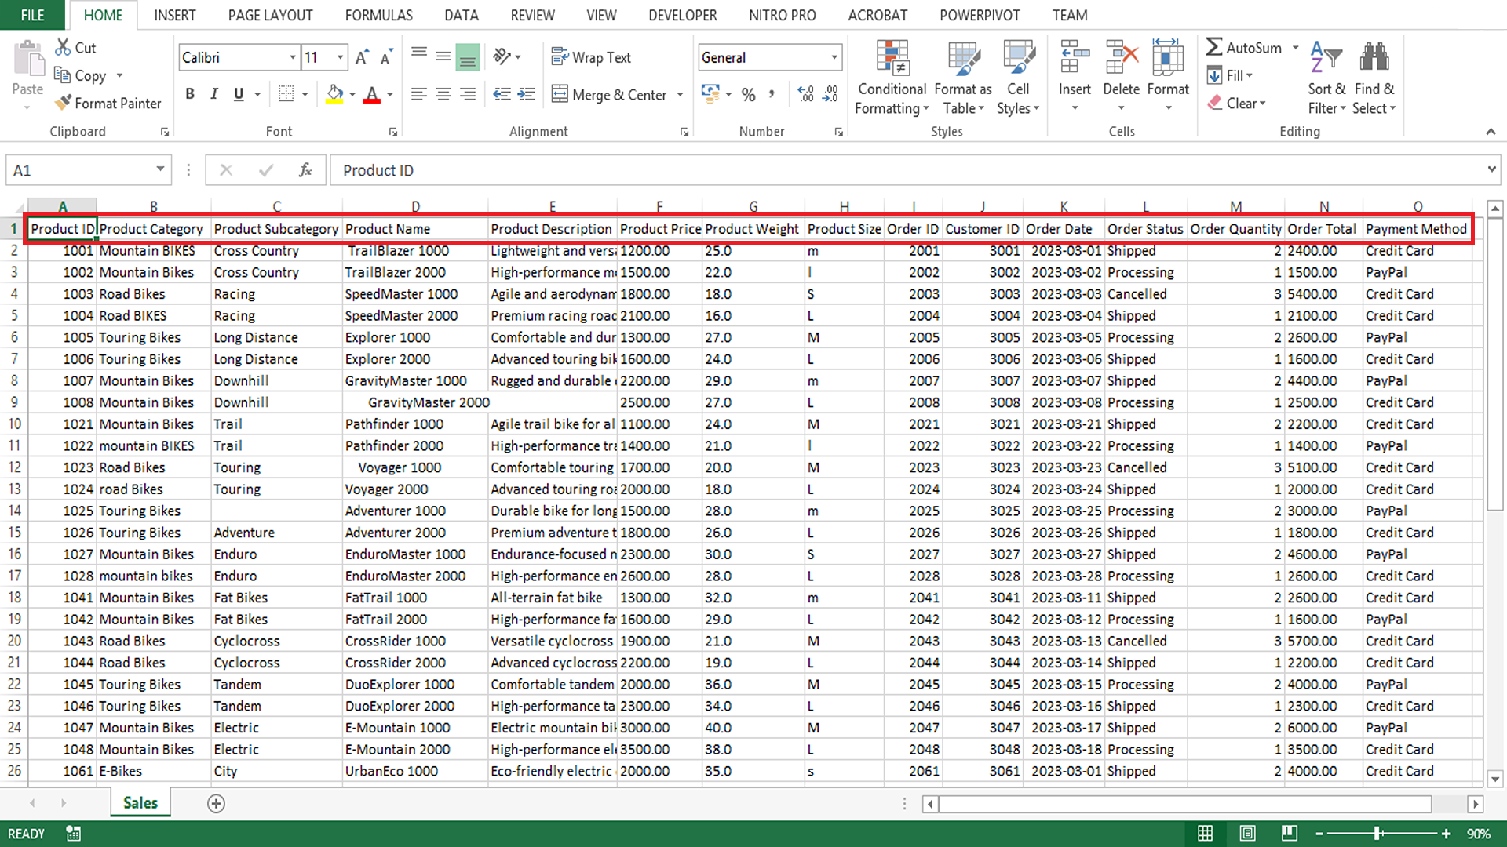
Although the sales dataset is the only data source provided in this exercise, business data ordinarily comes from multiple sources. In the current case study, additional relevant data sources may include customer details, marketing data, supply chain data, feedback data, and website analytics. As a result, part of the data analysis process may be integrating data from different sources to get a complete picture.
Answer the following questions to guide your understanding of data sources in the case study:
- What kind of information can you gather from the provided dataset in relation to product, order, and customer details?
- How can you use the data fields provided to understand sales trends and customer preferences? Briefly discuss your suggested approach for gaining insight into these two aspects separately.
- Explain how the other data sources within Adventure Works might be relevant to your analysis or add value to your insights.

Step 3: Data import and cleaning
Having identified your stakeholders and your data sources, the next step is to import your data and ensure it is clean and ready for analysis. Keep in mind that data often contains errors, duplicates, or missing values. This can compromise the integrity of your analysis, for example, resulting in Adventure Works making poor decisions related to the product launch based on incorrect data.
As a part of the data analysis process, you must evaluate the collected data to determine whether cleaning is required. For example, you may identify data inconsistencies or errors. Ensuring the data is clean and prepared for analysis is important for Adventure Works, as your analysis will help shape this launch in many ways, including marketing plans, sales strategies, and even final product changes.
Answer the following questions related to the data cleaning process:
- Name and briefly describe an Excel function that can help you clean the Product Name, Product Category, and Product Size columns.
- For the Adventure Works sales dataset, indicate the most appropriate Excel data type for the content of each column. For example, Product ID: Number.
- Explain how you could exclude the missing entry in the Product Description column in the Adventure Works sales dataset at the source using Excel.

Conclusion
Identifying and engaging with stakeholders, identifying data sources, and importing and cleaning the data are essential steps early in the data analysis process. The tasks you engaged with in this exercise can lay the groundwork for a successful data analysis project and can shape later stages in the analysis process. As a data analyst, the insights you draw from data can shape the course of a business and guide new product launches, as with Adventure Works. The power of data is immense, but the true power lies with the analyst who uncovers the insights within this data.

